**Afrikaans Language Monument**

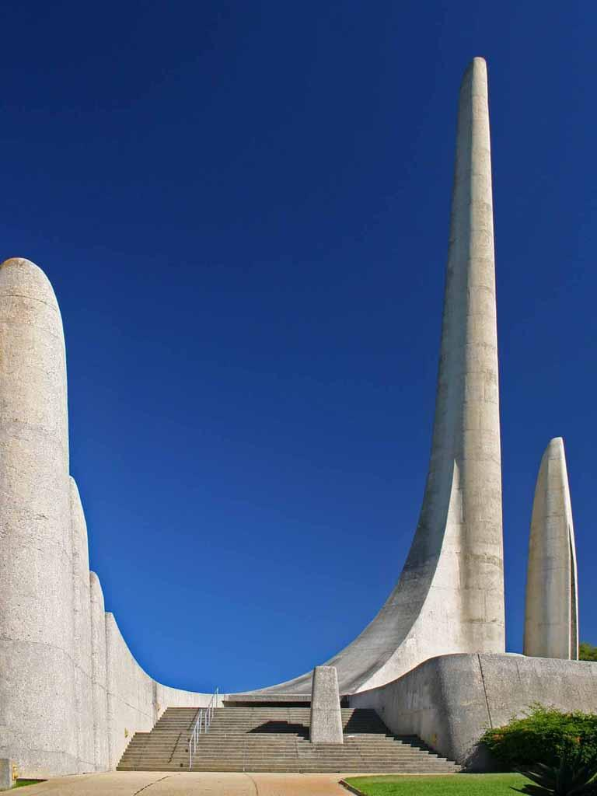

This unique language originated from the Dutch spoken by the first settlers. It was later evolved by people such as the Khoikoi and the slaves from other countries. The Afrikaans Language Museum and Monument celebrates this unique language. Afrikaans "just grew' from the soil of South Africa. In the human melting pot of the Cape it was inevitable that, from the original Dutch spoken by the first settlers, a colloquial form would be evolved by people such as the Khoikhoi and slaves from Malaya, Indonesia, Madagascar and West Africa.